AIRFOIL SELECTION AND AERODYNAMIC ANALYSIS
Problem 1 | Two RC aircraft with different mission priorities

1. Design brief and assumptions
Aircraft A is intended to carry the maximum practical payload while remaining stable in flight. Aircraft B is intended for manoeuvrability, including turns, rolls and loops. The sections below shortlist three candidates for each mission, retain their geometric descriptions and limitations, and then compare the aerodynamic trade-offs.
- Assume small, low-speed RC aircraft with negligible compressibility effects.
- Flight speed, chord, mass, wing area and atmospheric conditions were not supplied, so a single Reynolds number and defensible numerical CL/CD table cannot yet be calculated.
- Reynolds number: Re = ρVc/μ, where ρ is air density, V is speed, c is chord and μ is dynamic viscosity.

2. Aircraft A — Maximum payload + stable flight
Candidates: NACA 2412, NACA 4412 and Selig S1223. The selection prioritises sufficient lift at the intended low flight speed, manageable trim, and acceptable drag and stall behaviour.

NACA 2412
Why choose it?
- 2% of chord length = maximum camber.
- 40% of chord length = location of maximum camber from the front.
- 12% of chord length = maximum thickness.
- Its curved shape helps it generate lift even when the wing is at zero angle of attack.
- Its thickness provides space for a structural spar inside the wing.
- Its moderate camber generally produces a smaller nose-down pitching moment than NACA 4412, which may make balancing the aircraft easier.
Limitations:
- It may generate less lift than NACA 4412 at the same angle of attack.
- Less lift doesn't automatically mean less drag or better efficiency. We need to compare lift-to-drag ratios.
- Its performance depends on the aircraft's speed, angle of attack and Reynolds number.

NACA 4412
Why choose it?
- 4% of chord length = maximum camber.
- 40% of chord length = location of maximum camber from the front.
- 12% of chord length = maximum thickness.
- Its greater camber generally helps it generate more lift than NACA 2412 at the same angle of attack.
- Its 12% thickness provides space for a structural spar inside the wing.
- Higher lift could help the aircraft carry a payload, provided drag and stall performance are acceptable.
Limitations:
- Its greater camber generally creates a stronger nose-down pitching moment. The tail may need to produce more force to balance it, which can add drag.
- More lift doesn't necessarily mean better efficiency. It might also produce more drag, so we need to compare lift-to-drag ratios.
- Its advantage over NACA 2412 can change with speed, angle of attack and Reynolds number.

Selig S1223
- Maximum thickness = 12.1% of chord length, located at 19.8% of the chord from the front.
- Maximum camber = 8.1% of chord length, located at 49% of the chord from the front.
- It is a high-lift airfoil designed for low-Reynolds-number applications, making it worth considering for small RC aircraft.
- Its high camber helps it generate substantial lift, which could be useful for carrying a payload at relatively low speeds.
- Its thickness provides some room for a structural spar inside the wing.
Limitations:
- Its high lift doesn't automatically mean better efficiency; it may also produce considerable drag.
- Its highly cambered shape can create a stronger pitching moment, so the tail may need to produce more force to balance the aircraft, potentially adding drag.
- Its performance depends on speed, angle of attack and Reynolds number, so it needs to be compared with NACA 2412 and 4412 under the same conditions.

Aircraft A selection

Provisional choice: NACA 2412. It is a balanced starting point among the three candidates, offering moderate camber to generate lift at relatively low angles of attack and 12% thickness to provide room for a structural spar. NACA 4412 is worth evaluating if generating greater lift is the priority, while Selig S1223 is worth considering for its high-lift capability at low Reynolds numbers. However, greater lift does not automatically mean better efficiency: drag, pitching moment and trim requirements must also be considered. The final choice should be based on comparing lift-to-drag ratio, maximum lift coefficient and pitching moment at the aircraft's operating conditions.

3. Aircraft B — Maneuverability (turns, rolls and loops)
Candidates: NACA 0012, NACA 0009 and NACA 0015. A symmetrical section is attractive because its lift behaviour is more similar at positive and negative angles of attack, helping with upright and inverted flight.

NACA 0012
Why choose it?
- 0% camber = symmetrical airfoil.
- 12% of chord length = maximum thickness.
- Its symmetrical shape lets it generate lift in either direction by changing the angle of attack.
- This makes it suitable for upright and inverted flight.
- Its 12% thickness provides space for a structural spar.
Limitations:
- It generates approximately zero lift at zero angle of attack, so it needs a suitable angle of attack to generate lift.
- Symmetry alone doesn't guarantee good aerobatic performance. Motor power and aircraft balance matter too.
- Its drag and maximum lift must be checked at the conditions in which the aircraft will manoeuvre.

NACA 0009
Why choose it?
- 0% camber = symmetrical airfoil.
- 9% of chord length = maximum thickness.
- Its symmetrical shape supports both upright and inverted flight.
- Its smaller thickness may reduce profile drag under some conditions.
Limitations:
- Its thinner shape provides less room for a structural spar.
- A thinner airfoil doesn't automatically produce less drag in every situation.
- Its structural strength and aerodynamic performance need to be checked for the intended manoeuvres.

NACA 0015
Why choose it?
- 0% camber = symmetrical airfoil.
- 15% of chord length = maximum thickness.
- Its symmetrical shape supports both upright and inverted flight.
- Its greater thickness can provide more room for structural components inside the wing.
Limitations:
- Greater thickness may increase parasite drag under some conditions.
- More thickness doesn't automatically mean a stronger wing; spar design and construction also matter.
- Its performance needs to be compared with thinner airfoils at the same Reynolds number and operating conditions.

Aircraft B selection
Provisional choice: NACA 0012. It is a balanced starting point among the three symmetrical candidates, offering more internal depth than NACA 0009 without the additional thickness of NACA 0015. NACA 0009 is worth evaluating if reducing parasite drag is important and the structure can still be made sufficiently stiff. Actual aerobatic capability also depends strongly on wing loading, mass distribution and structural stiffness.

4. Comparison table: geometry and aerodynamic behaviour
Since the flight conditions were not specified and no XFLR5/XFOIL run has been performed here, the table reports geometry and defensible qualitative tendencies rather than fabricated numbers.
Airfoil | Camber; thickness | Lift coefficient (CL) | Drag coefficient (CD) / L/D | Stall / pitching moment
NACA 2412 | 2% at 40% chord; 12% thick | Moderate camber; typically positive lift at α=0° | Drag depends on flight conditions. Efficiency should be compared with NACA 4412 using (L/D). | Moderate camber produces less negative pitching moment than NACA 4412.
NACA 4412 | 4% at 40% chord; 12% thick | Often higher CL than 2412 at the same α before stall | May generate more lift than NACA 2412 doesn’t necessarily mean better efficiency as drag may also increase. | Greater camber produces more negative pitching moment than NACA 2412.
Selig S1223 | 8.1% at 49%; 12.1% thick | Designed for high lift at low Re; reported CL,max ≈2.2 at Re≈200,000 in published test conditions | High lift does not guarantee high L/D. Efficiency must be evaluated | Highly cambered geometry may produce substantial pitching moment. Actual magnitude using aerodynamic data.
NACA 0012 | 0%; 12% thick | Approximately CL=0 at α=0°; sign changes with α | Drag depends on speed and angle of attack. Efficiency should be evaluated. | Symmetric response supports inverted flight
NACA 0009 | 0%; 9% thick | Approximately CL=0 at α=0°; sign changes with α | Thinner shape may reduce drag under some conditions, not guaranteed in every flight condition. | Less depth for spar; confirm stall and structural behaviour
NACA 0015 | 0%; 15% thick | Approximately CL=0 at α=0°; sign changes with α | Thickness can affect drag; outcome is condition-dependent | More depth for spar, but thickness alone does not guarantee strength

5. Airfoil geometry and whole-aircraft performance
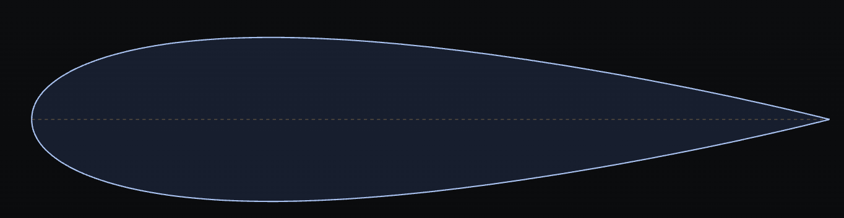
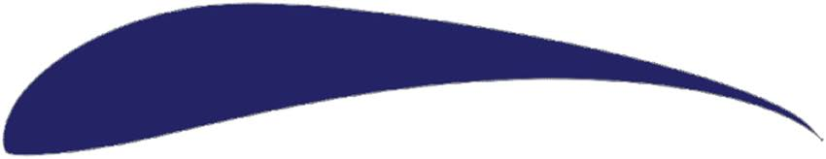
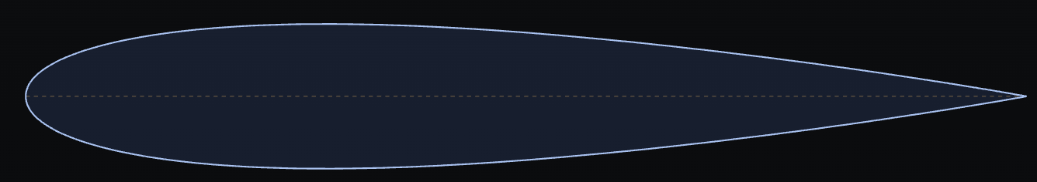
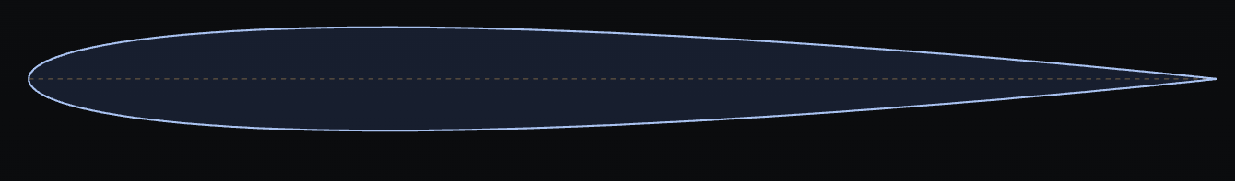
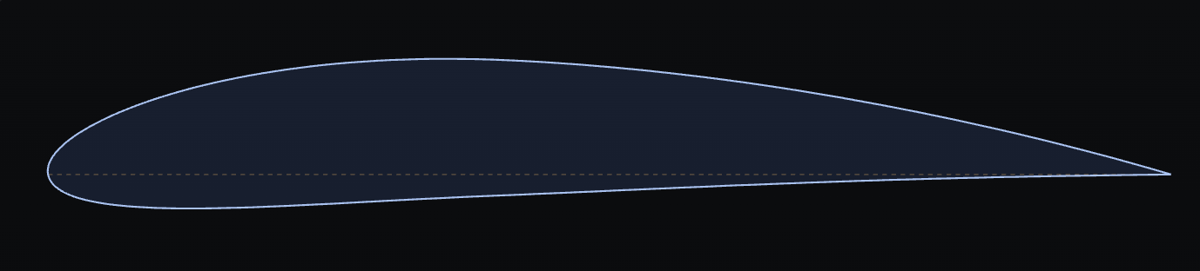
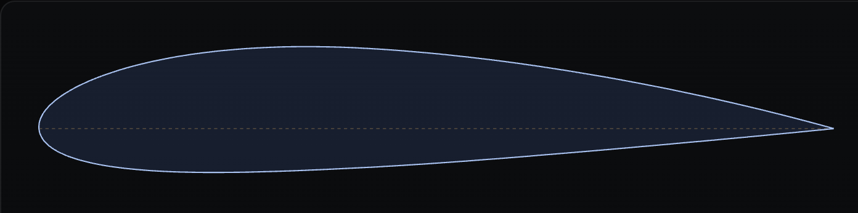
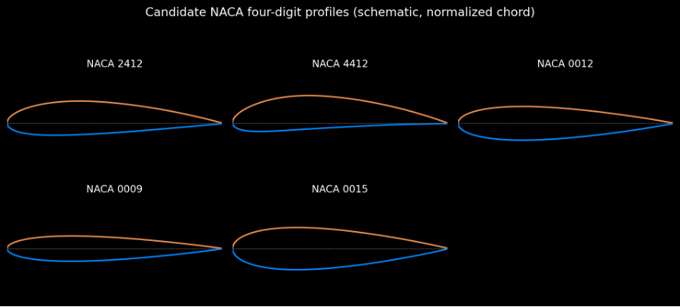
Selig S1223
Figure 1. Schematic NACA four-digit profiles.
Airfoil-level characteristics | Whole-aircraft factors
Camber, thickness distribution, leading-edge radius and pressure recovery | Wing area, span, aspect ratio, taper, twist and planform
Section CL, CD, pitching moment and section stall | Wing loading (weight/wing area), aircraft mass and centre of gravity
Reynolds-number and surface-finish sensitivity | Tail volume, static margin, control surface size and servo authority
Available depth for a spar (geometric opportunity only) | Spar/skin materials, joints, stiffness, load cases and safety factor
Section aerodynamic performance | Motor/propeller thrust, power, battery and flight-control setup
A thicker section can create more room for a spar, but strength depends on the spar design and materials. Likewise, a high section CL,max does not by itself determine payload capacity: wing area, total weight, power and stall margin matter.

Can one airfoil satisfy both missions?
Yes, one airfoil could be used for both missions, but it would involve trade-offs. NACA 0012, for example, could be a reasonable compromise because its symmetrical shape supports both upright and inverted flight, while its 12% thickness provides room for a structural spar. However, a cambered airfoil such as NACA 2412 may be more suitable for conventional payload flight, where generating lift efficiently is important. Conversely, a highly cambered airfoil such as Selig S1223 is designed for high lift but may involve greater drag and pitching-moment challenges. Ultimately, the best choice depends on the required lift, drag, stability and maneuverability. A single airfoil can serve both missions, but separate airfoils may perform better when each aircraft is optimised for its specific purpose.

6. Bonus task: XFLR5/XFOIL validation plan
The numerical solver comparison is not claimed as completed. To complete the +5 bonus, run all six profiles at the same representative Reynolds number and with identical modelling assumptions.
- Estimate Re = ρVc/μ using the intended flight speed and chord.
- Import verified coordinate files, especially the actual S1223 coordinates.
- Run an angle-of-attack sweep and export CL vs α, CD vs α, CL/CD vs α and CM vs α.
- Use the same Re, Mach number, transition/Ncrit settings and convergence criteria for every airfoil.
- Compare CL,max, drag at the mission lift coefficient, peak L/D, pitching moment and predicted stall onset. Treat XFOIL results near stall cautiously and compare with experimental data when possible.

References
- [1] Selig, M. S. & Guglielmo, J. J. (1997). “High-Lift Low Reynolds Number Airfoil Design.” Journal of Aircraft, 34(1), 72–79. DOI: 10.2514/2.2137. https://m-selig.ae.illinois.edu/pubs/GuglielmoSelig-1997-JofAC-S1223.pdf
- [2] UIUC Applied Aerodynamics Group, UIUC Airfoil Coordinates Database. https://m-selig.ae.illinois.edu/ads/coord_database.html
- [3] UIUC Airfoil Data Site, low-Reynolds-number airfoil resources. https://m-selig.ae.illinois.edu/ads.html
- [4] “Design and Structural Analyses of a Reciprocating S1223 High-Lift Wing for an RA-Driven VTOL UAV.” Aerospace, 8(8), 214 (2021). https://www.mdpi.com/2226-4310/8/8/214

